Assignment 1: Subject: MPCA
Chapter 1: Overview of Computer and Microprocessor
- Differentiate between Microprocessor and Microcontroller.
- Differentiate between Von-Neumann and Harvard Architecture with suitable block diagrams.
- Explain the phases in instruction cycle.
- What are the applications of Microprocessor? Briefly explain.
- What are the applications of Microcontroller? Briefly explain.
- Explain the basic computer organization.
- Explain the linear organization of 8x2 ROM chip.
- Explain the horizontal organization of 8x2 ROM chip.
- Construct an 8x4 ROM from two 8x2 ROMs. Also explain it.
- Construct an 8x4 ROM from two 8x2 ROMs using high-order interleaving. Also explain it.
- Construct an 8x4 ROM from two 8x2 ROMs using low-order interleaving. Also explain it.
- Design a 16x4 memory subsystem with high order interleaving using 8x2 memory chips for a computer system with an 8-bit address bus.
- Design a 16x4 memory subsystem with low order interleaving using 8x2 memory chips for a computer system with an 8-bit address bus.
- Design an interface for an input device which has binary address 1010 1010. Its computer system uses isolated I/0.
- Design an interface for an input device which has binary address 1010 1010. Its computer system uses memory mapped I/O.
- Design an interface for a bidirectional Input/output device that has binary address 1000 0001. Its computer system uses Isolated I/O.
- A CPU with 8-bit data bus and 8-bit address bus uses memory mapped I/O. It has 32 byte of ROM at 00H and 32 byte of ROM at 20H. It also has an I/O device at FFH. Show the load logic and enable logic.
- A computer system with an 8-bit address and an 8-bit data bus using isolated I/O. It has 16 x 8 ROM starting at address 00H constructed using 8 x8 chips; 64 x 8 of RAM starting at address 80H constructed using 64 x 4 chips. There is an I/O device at 40H. Show the design for the system.
- 8. A computer system with 8-bit data bus and 8-bit control bus uses isolated I/O. It has 64 bytes of ROM starting at 00H constructed using 64 x 4 chips; 128 bytes of RAM, starting at address 40H constructed using 32 x 8 chips; an input device with READY signal at address 40H; and an output with no READY signal at address 80H. Show the design for this system. Include all enable and load logic.
- A computer has a CPU with 8-bit address bus and 16-bit data bus. The computer uses Isolated I/O. It has 64 x 16 of ROM at 00 H; constructed using two 32 x 16 ROM chips. It also has 32 x16 of RAM at C0 H. The system has an input device at 17 H and an output device at B5 H. Show the design for the system including all the required logic. [PU 2018 Fall]
- A computer system with an 8-bit address bus and an 8-bit data bus uses memory-mapped I/O. It has 32 bytes of ROM starting at address 00H constructed using a single 32x8 chip; 128 bytes of RAM starting at address 80H constructed using 64x4 chips; a bidirectional I/O device with no READY signal at address 40H; and an input device with no READY signal at address 60H. Show the design for this system. Include all enable and load logic.

Chapter 4: CPU design and Chapter 5: Micro-sequencer Control Unit Design
- Design a CPU for below:
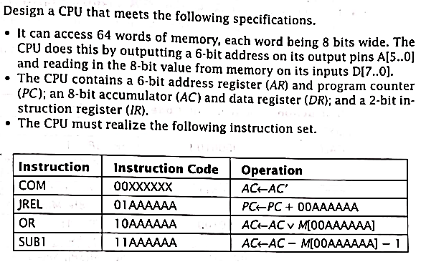

- Design the hardwired CU for question no 16
- Design a microsequencer control unit with horizontal microcode for the CPU described in question no. 16
- Design a microsequencer control unit with vertical microcode for the CPU described in question no. 16
- Design a microsequencer control unit which directly generate control signals for the CPU described in question no. 16
- There is a very simple CPU for the given set of Instruction:
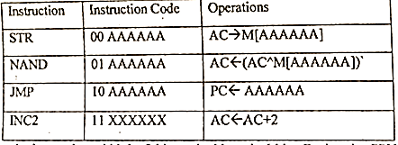
Let the instruction width be 8 bits and address is 6 bits. Design the CPU’s register section, state diagram and ALU
- Design the hardwired control unit for the CPU described in above question.
- Design a microsequencer control unit with horizontal microcode for the CPU described in question no. 21
- Design a microsequencer control unit with vertical microcode for the CPU described in question no. 21
- Design a microsequencer control unit which directly generate control signals for the CPU described in question no. 21

Chapter 6: Arithmetic Unit
- Trace RTL code to multiply 3x5 using shift add algorithm.
- Trace RTL code to multiply -7 x -9 using Booth’s algorithm.

Chapter 7: Memory Organization
- Explain memory hierarchy.
- Explain Associative memory with its block diagram.
- Explain different cache mapping techniques.
Assignment 2: Subject: MPCA
Chapter 2: 8085 MP
- Explain 8085 Microprocessor with its block diagram.
- What are accumulator and PC?
- Explain the 8085 pin configuration in brief.
- Define instruction. Classify 8085 instruction set and discuss in brief.
- Explain the address modes in 8085.
- What are instruction cycle, machine cycle and T-state and Timing diagram?
- Explain different types of machine cycle.
- Explain opcode fetch machine cycle with its timing diagram.
- Explain memory read/write machine cycle with its timing diagram.
- Explain IO read/write machine cycle with its timing diagram.
- Draw the timing diagram for MOV A,B
- Draw the timing diagram for MVI A, 43H
- Draw the timing diagram for STA 2050H
- Write an ALP for subtracting two 8-bit numbers stored in 2501H and 2502H. The result is to be stored in 2503H.
- Write an assembly language program to add two 8-bit numbers (F1 and 15), stored at C050H and C051H, with carry.
- Write a program in Assembly language to interchange(Swap) the contents of two memory location 2100H and 2101H.
- Define RTL. Consider a system with four 1-bit flipflops. Given RTL code where j, o, h and n are conditions which are mutually exclusive. Draw its hardware implementation.
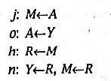
- What are the uses of 8085 MP? Mention the issues in 8085.

Chapter 3: 8086 MP
- Explain the 8086 MP architecture with its block diagram.
- Explain the pin configuration of 8086 in brief.
- Explain different flags used in 8086 MP.
- Explain different General-purpose registers in 8086 MP.
- Explain different segment registers in 8086 MP.
- Explain the addressing modes of 8086 MP.
- Compare 8085 and 8086 MPs.
- What is editor, assembler and linker?

Chapter 7: IO organization
- Differentiate between Serial and Parallel Communication.
- Differentiate between Serial Interface and Parallel Interface.
- What is IO operation? Explain in brief about the different modes of IO transfer.
- Explain Programmed IO with a diagram.
- Explain Interrupt-driven IO.
- Explain DMA technique.
- What are the different types of interrupts? Explain in short.
- How interrupt processing is done? Explain.
- Explain priority arbitration with block diagram.
- Explain daisy chain arbitration with block diagram.
- What are IO processors? Explain.
- Describe UART.
Chapter 9: Advanced Architecture.
- Differentiate between RISC and CISC.
- Explain RISC instruction pipelining with different stages.
- What is register window? In a RISC processor system, there are 10 global registers and 8 register windows, each having 4 common input registers, 10 local registers, and 4 common output registers. How many registers are in this CPU? Also show the diagrammatic representation.
- Explain Flynn’s classification for multiprocessors.
- Explain different topologies for connection of multiprocessors.
- Explain UMA and NUMA.
- How can memory be accessed or shared in multiprocessors architecture? Explain each of them.
- What is cache coherence? Explain.
- Introduce multicore architecture with necessary diagrams.

